|  |  |
| --- | --- |
| 0cm – 5cm | Organic soil |
| 5cm – 46cm | Very fine sand, brownish gray |
| 46cm – 74cm | Very fine sand, slightly clayey, brownish orange |
| 74cm – 104cm | Fine to medium sand, no clay, with stray gravel pieces, brownish orange |
| 104cm – 140cm | Fine to medium sand, powdery, no gravel, brownish orange |
| 140cm – 175cm | Fine to medium sand with some gravel, grayish brown |

Sample: DB11, apex of Carolina bay sand rim

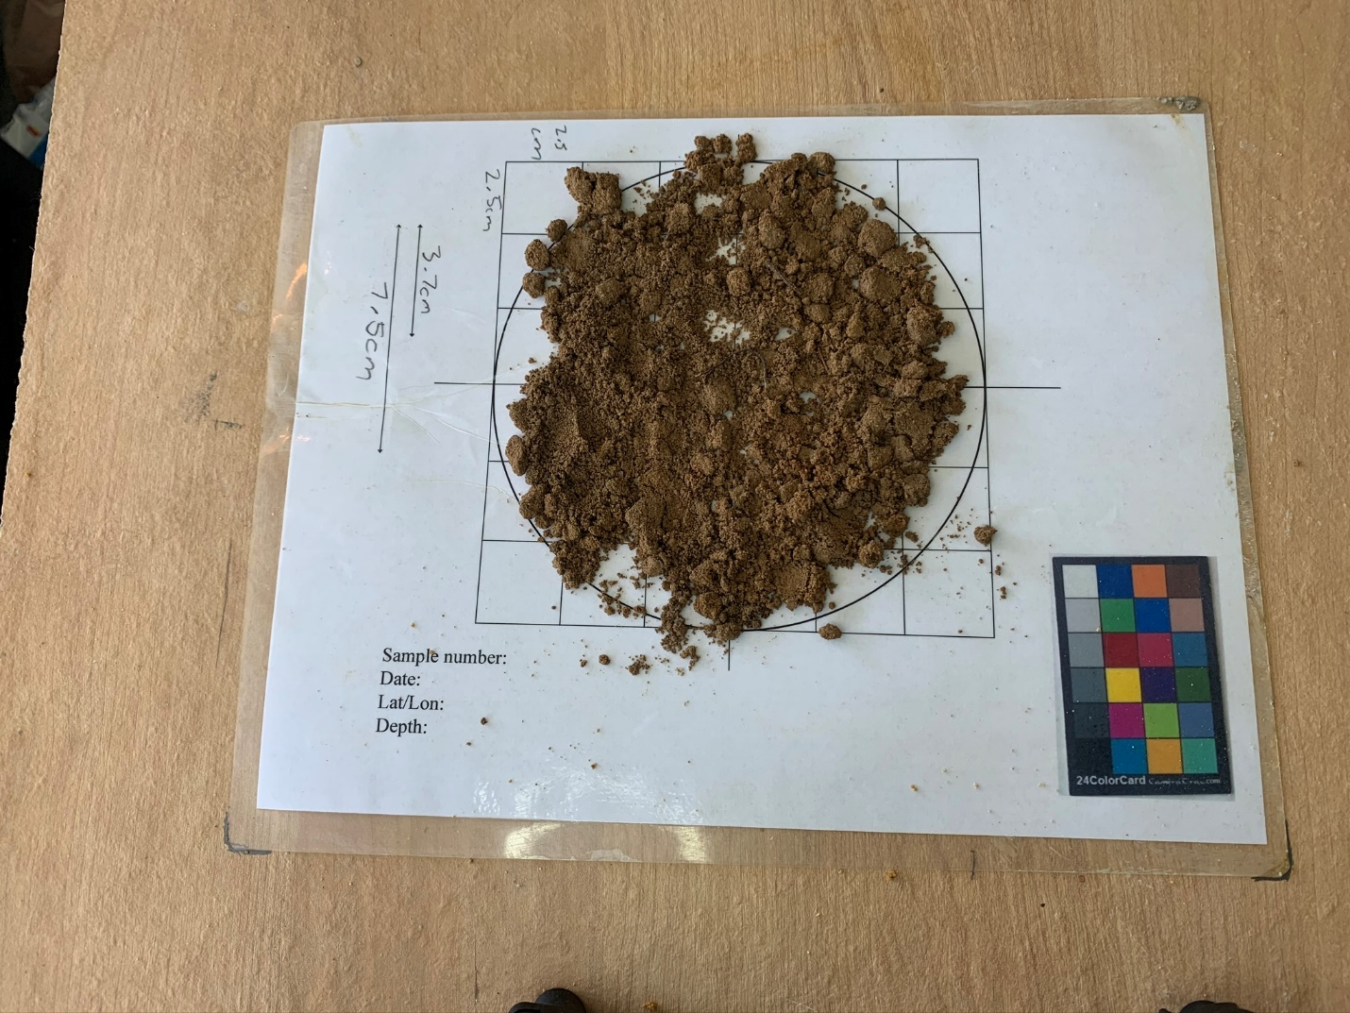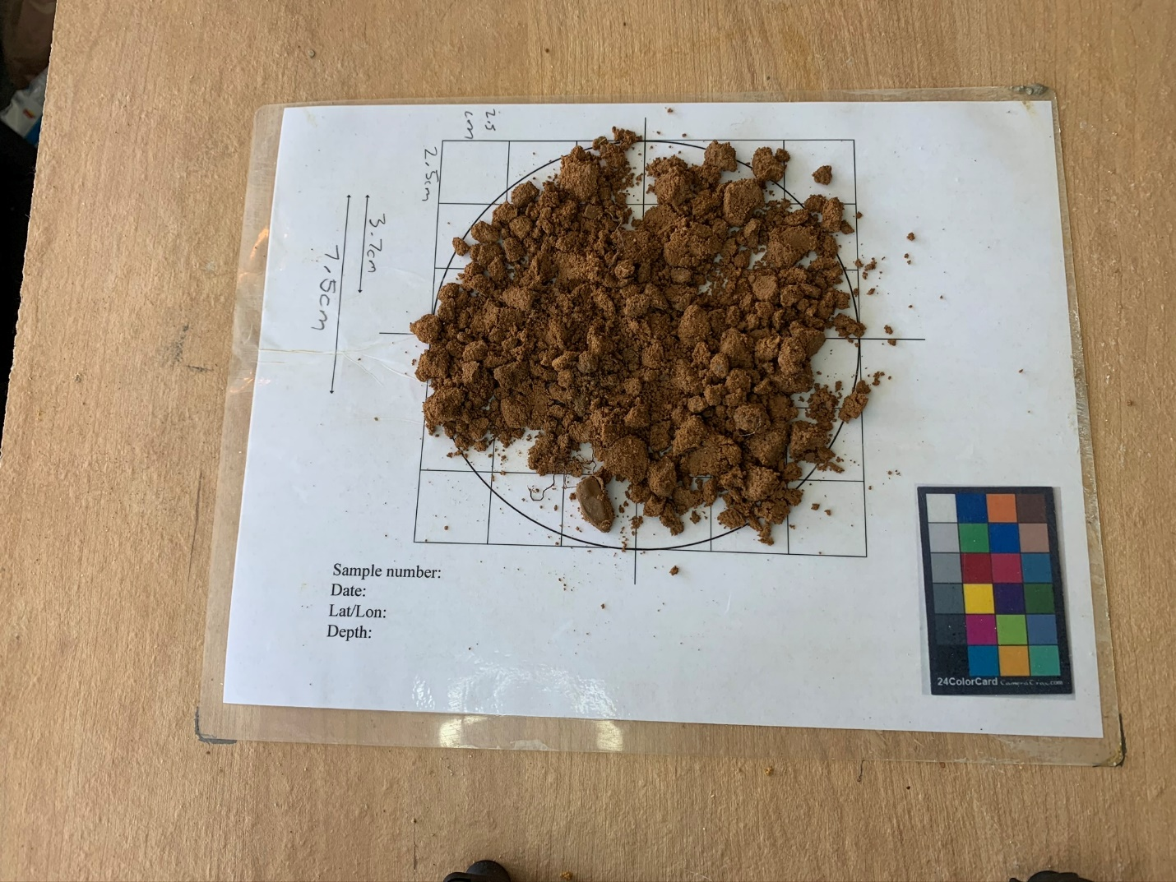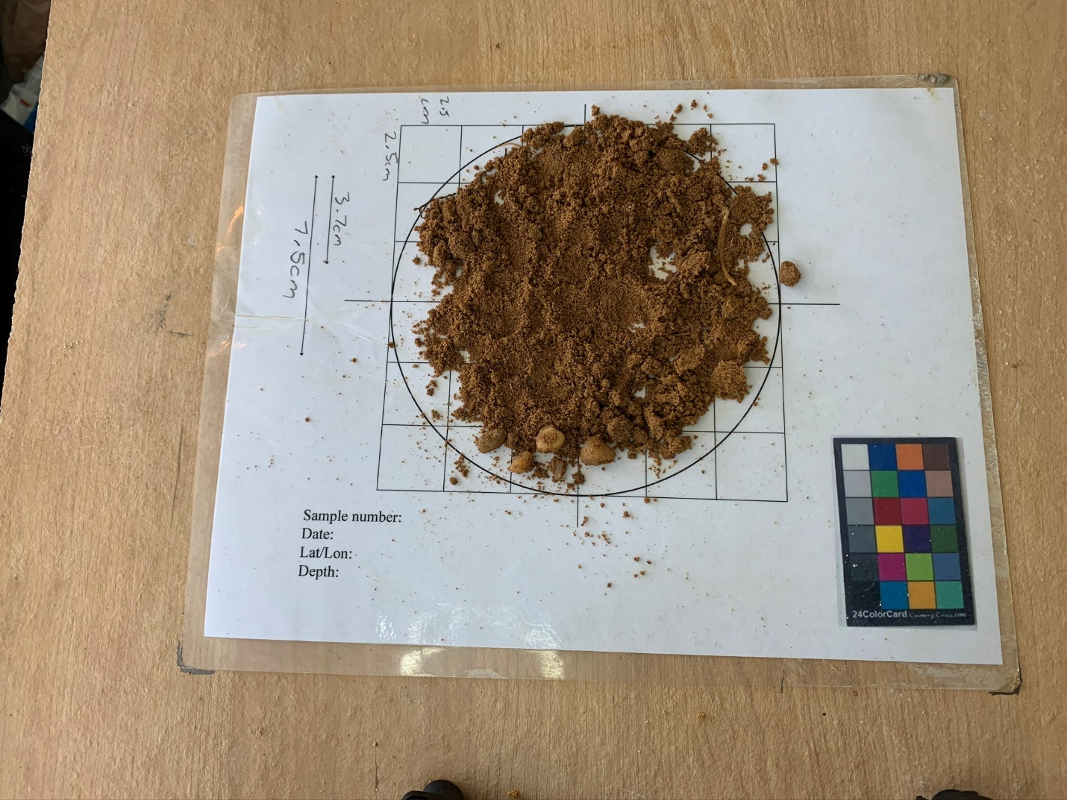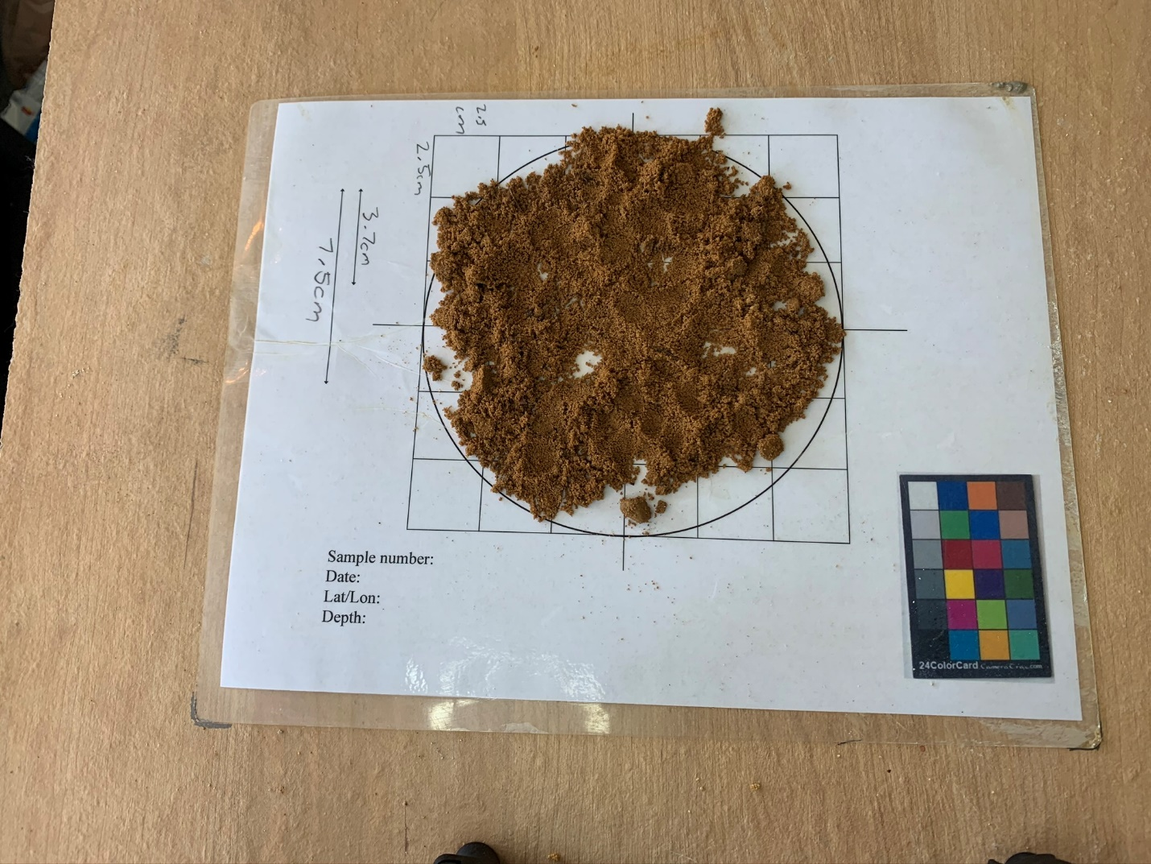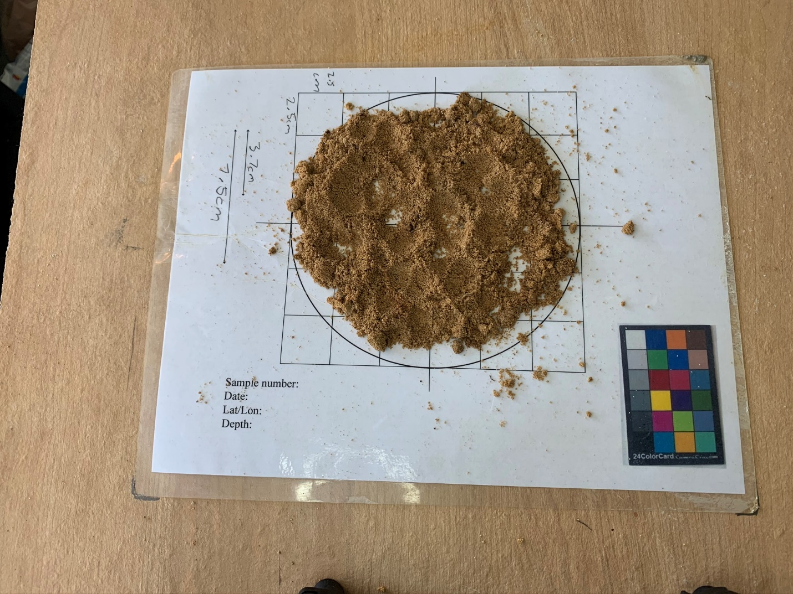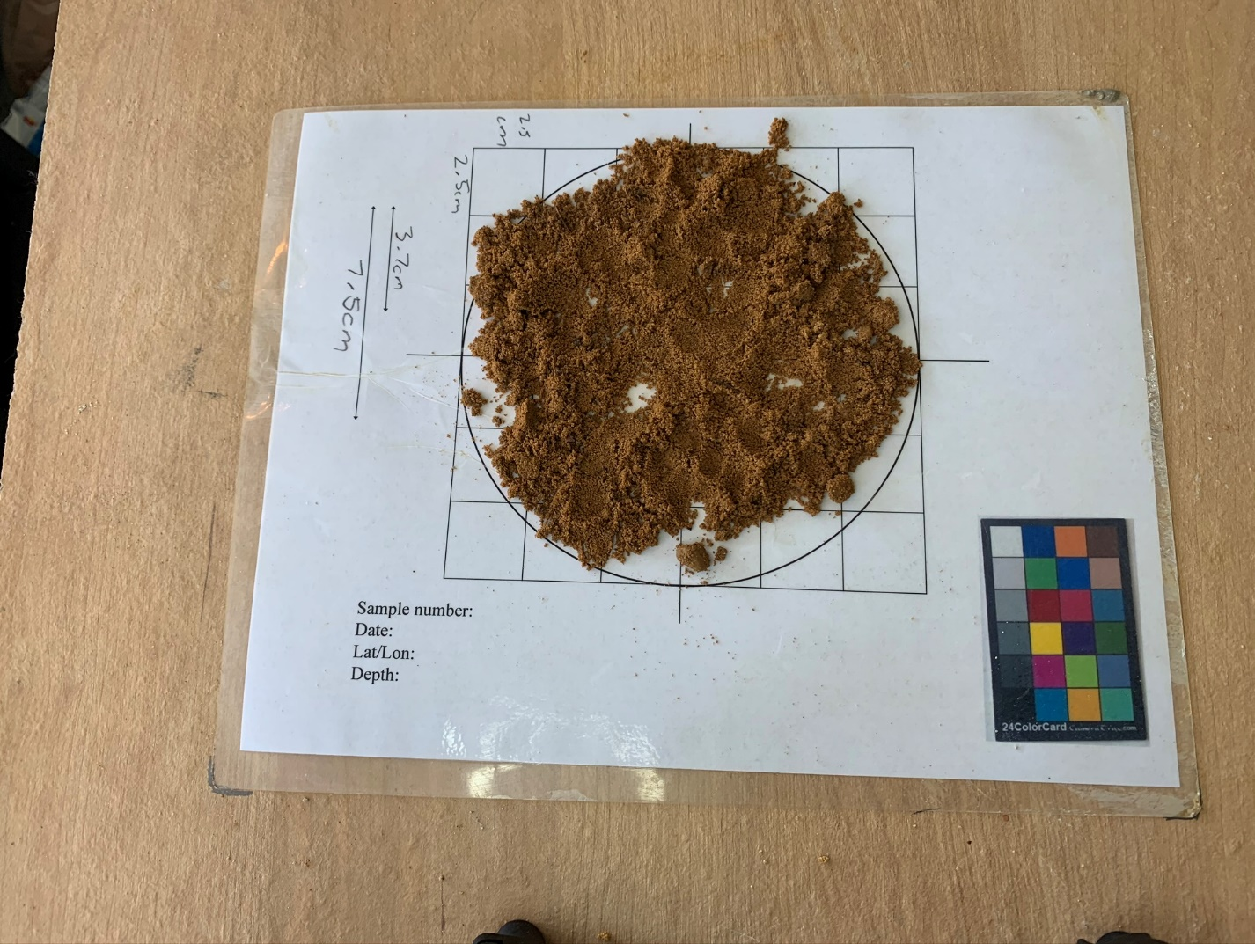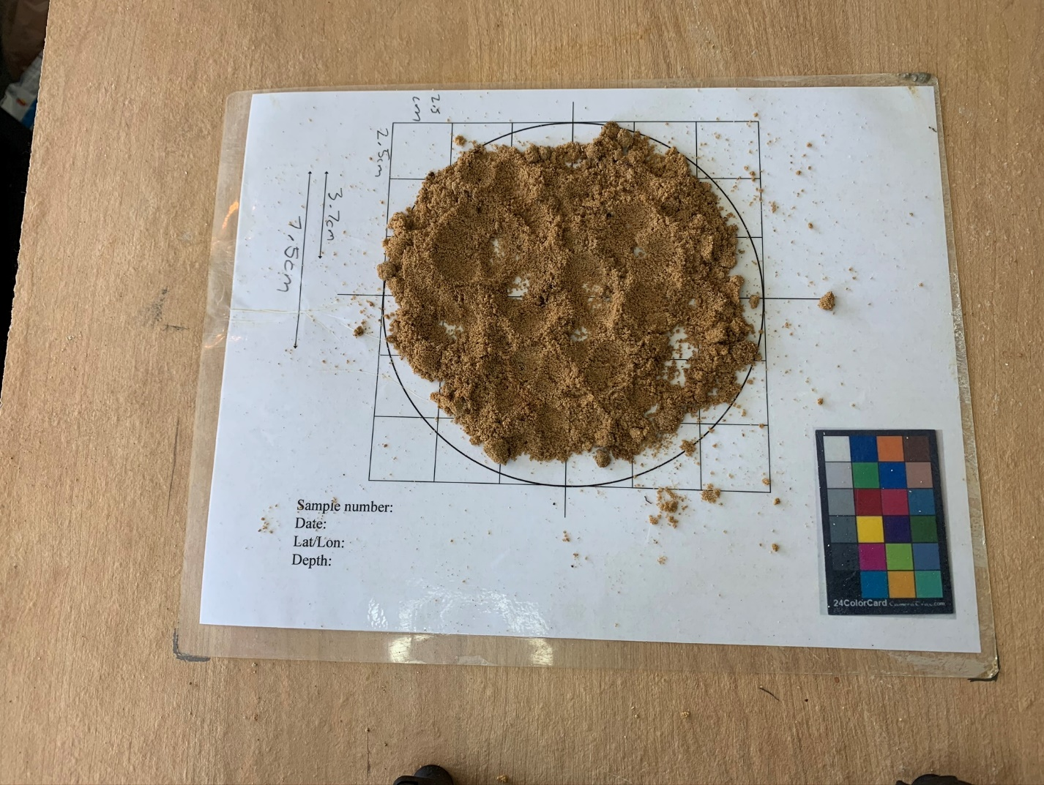

|  |  |
| --- | --- |
| 175cm – 201cm | Fine to medium sand with gravel, brownish orange color |
| 201cm – 206cm | Fine to medium to coarse sand with gravel, grayish brown color, Likely Columbia Formation |

